**Aim:** Working over Tableau

**IDE:** Microsoft Excel, Tableau

**Pre-Requisites:-**  Insert the Customer’s Full Name, Gender, City, and Country From the Customer Sheet Using VLOOKUP

Function In Order Dataset In Excel Itself on the Basis of Customer ID.

**Now Import Necessary Libraries for Analysis:-**

import pandas as pd

import numpy as np

import seaborn as sns

import matplotlib.pyplot as plt

Dataset = pd.read_excel("D:/Aryan Data/Usefull Data/Semester - 4/Data Visulization and Dashboards/Assigments/Assignment 4 working over Python/excel_pivots.xlsx" , 'Orders')

Dataset['Order_Date'] = pd.to_datetime(Dataset['Order_Date'])

Dataset["Year"] = Dataset["Order_Date"].dt.year

Dataset["Quater"] = Dataset["Order_Date"].dt.quarter

Dataset["Month"] = Dataset["Order_Date"].dt.month

**Questions:**

1. **Average "total cost" and count of the product 1 under normal order category**

**Code:-**

Order_With_Normal_Category_of_Product_1 = Dataset[(Dataset["Order_Category"] == "Normal Order")& (Dataset["Product_#"] == "Product 1")]

Count_of_Order_With_Normal_Category_of_Product_1 = Order_With_Normal_Category_of_Product_1.shape[0]

Average_Total_Cost_of_Order_With_Normal_Category_of_Product_1 = Order_With_Normal_Category_of_Product_1["Total_Cost"].mean()

print(f"The Average Total Cost For Product 1 In Normal Category Is $ {Average_Total_Cost_of_Order_With_Normal_Category_of_Product_1} and the Count of Orders are {Count_of_Order_With_Normal_Category_of_Product_1}.")

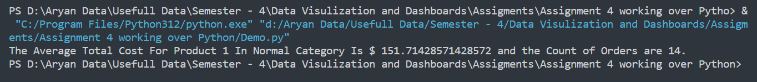**Output:-**

1. **Average "total cost" and count of product 1 under the short order category**

**Code :-**

Order_With_Small_Category_of_Product_1 = Dataset[

(Dataset["Order_Category"] == "Small Order") & (Dataset["Product_#"] == "Product 1")

]

Count_of_Order_With_Small_Category_of_Product_1 = (

Order_With_Small_Category_of_Product_1.shape[0]

)

Average_Total_Cost_Order_With_Small_Category_of_Product_1 = (

Order_With_Small_Category_of_Product_1["Total_Cost"].mean()

)

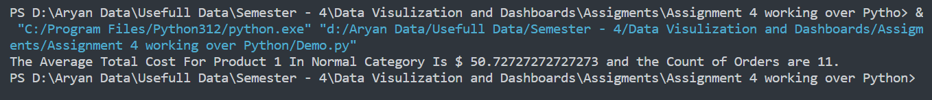**Output :-**

1. **Average "total cost" and count of product 1 under the large order category**

**Code :-**

Order_With_Large_Category_of_Product_1 = Dataset[

(Dataset["Order_Category"] == "Large Order") & (Dataset["Product_#"] == "Product 1")

]

Count_of_Order_With_Large_Category_of_Product_1 = (

Order_With_Large_Category_of_Product_1.shape[0]

)

Average_Total_Cost_Order_With_Large_Category_of_Product_1 = (

Order_With_Large_Category_of_Product_1["Total_Cost"].mean()

)

print(

f"The Average Total Cost For Product 1 In Normal Category Is $ {Average_Total_Cost_Order_With_Large_Category_of_Product_1} and the Count of Orders are {Count_of_Order_With_Large_Category_of_Product_1}."

)

**Output :-**

1. **Which month has the highest count of orders placed?**

**Code :-**

Dataset["Order_Date"] = pd.to_datetime(Dataset["Order_Date"])

Dataset["Month"] = Dataset["Order_Date"].dt.month

Month_Having_Highest_Count = Dataset["Month"].mode()[0]

print(f"The {Month_Having_Highest_Count} th Month Has the Highest Count of Orders.")

**Output :-**

1. **Which year has the highest "average total cost"?**

**Code :-**

Dataset["Order_Date"] = pd.to_datetime(Dataset["Order_Date"])

Dataset["Year"] = Dataset["Order_Date"].dt.year

Year_Wise_Average_Total_Cost = Dataset.groupby("Year")["Total_Cost"].mean()

Year_Having_Highest_Average_Total_Cost = Year_Wise_Average_Total_Cost.idxmax()

print(

f"The Year - {Year_Having_Highest_Average_Total_Cost} Has The Highest Average Total Cost."

)

**Output :-**

1. **What is the ratio of the number of orders placed by males and females?**

**Code :-**

Orders_Given_By_Male_Customers = Dataset[(Dataset["Gender"] == "Male")]

Orders_Given_By_Female_Customers = Dataset[(Dataset["Gender"] == "Female")]

Count_of_Orders_Given_By_Male_Customers = Orders_Given_By_Male_Customers.shape[0]

Count_of_Orders_Given_By_Female_Customers = Orders_Given_By_Female_Customers.shape[0]

Ratio_of_Count_of_Orders_Given_By_Males = (

Count_of_Orders_Given_By_Male_Customers / Dataset.shape[0]

) * 100

Ratio_of_Count_of_Orders_Given_By_Females = (

Count_of_Orders_Given_By_Female_Customers / Dataset.shape[0]

) * 100

print(

f"The Ratio Of The Number of Orders Placed By Males and Females are :-\nMales - {Ratio_of_Count_of_Orders_Given_By_Males} %\nFemales - {Ratio_of_Count_of_Orders_Given_By_Females} %"

)

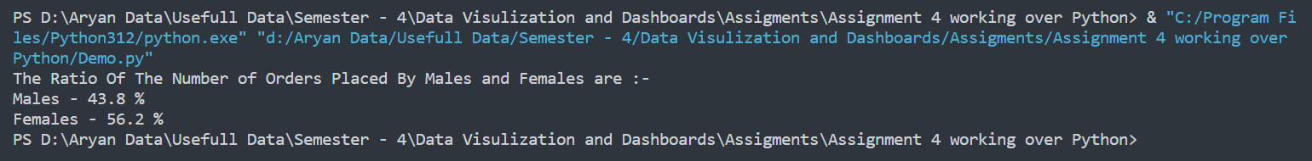**Output:-**

1. **What is the ratio of the total cost of the orders placed by males and females?**

**Code :-**

Orders_Given_By_Male_Customers = Dataset[(Dataset["Gender"] == "Male")]

Orders_Given_By_Female_Customers = Dataset[(Dataset["Gender"] == "Female")]

Total_Cost_of_Orders_Given_By_Males = Orders_Given_By_Male_Customers["Total_Cost"].sum()

Total_Cost_of_Orders_Given_By_Females = Orders_Given_By_Female_Customers[

"Total_Cost"

].sum()

Ratio_of_Total_Cost_of_Orders_Given_By_Males = (

Total_Cost_of_Orders_Given_By_Males / Dataset["Total_Cost"].sum()

) * 100

Ratio_of_Total_Cost_of_Orders_Given_By_Females = (

Total_Cost_of_Orders_Given_By_Females / Dataset["Total_Cost"].sum()

) * 100

print(

f"The Ratio Of The Total Cost of Orders Placed By Males and Females are :-\nMales - {Ratio_of_Total_Cost_of_Orders_Given_By_Males} %\nFemales - {Ratio_of_Total_Cost_of_Orders_Given_By_Females} %"

)

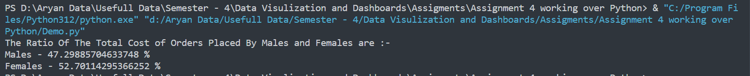**Output :-**

1. **How many orders are placed under each order category for the country "INDIA"?**

**Code :-**

Orders_Placed_In_India = Dataset[Dataset["Country"] == "India"][

"Order_Category"

].value_counts()

print(f"Category Wise Number of Order Placed :-\n{Orders_Placed_In_India}")

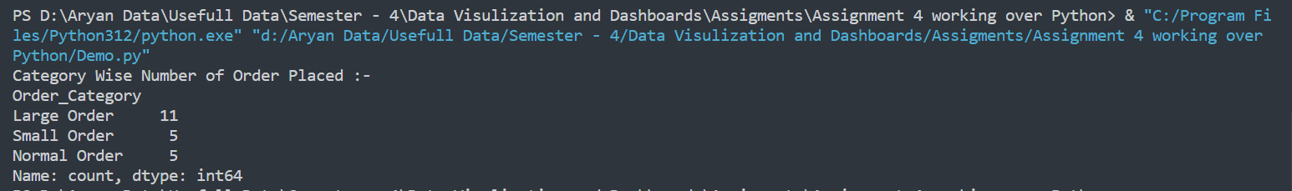**Output :-**

1. **What is the total cost of the order placed by the customer "Willis Brinks"?**

**Code :-**

Order_Placed_By_Willis_Brinks = Dataset[Dataset["Full_Name"] == "Willis Brinks"]

Total_Cost_of_Orders_by_Willis_Brinks = Order_Placed_By_Willis_Brinks[

"Total_Cost"

].sum()

print(

f"The Total Cost Of Orders Placed By Willis Brinks Is $ {Total_Cost_of_Orders_by_Willis_Brinks}"

)

**Output :-**

1. **Name the customer who has placed the order with the highest amount.**

**Code :-**

Name_of_Highest_Amount_Order = Dataset.loc[Dataset["Total_Cost"].idxmax(), "Full_Name"]

Order_Value = Dataset.loc[Dataset["Total_Cost"].idxmax(), "Total_Cost"]

print(

f"{Name_of_Highest_Amount_Order} Has Placed The Order With The Highest Amount Which Is $ {Order_Value}."

)

**Output :-**

1. **What is the most common order quantity?**

**Code :-**

Most_Common_Order_Quantity = Dataset["Quantity"].mode()[0]

print(f"{Most_Common_Order_Quantity} Is the Most Common Order Frequency.")

**Output :-**

1. **Are there specific quarters with higher order volumes?**

**Code:-**

Quater_Wise_Order = Dataset["Quater"].value_counts()

print(f"Quarter Wise Order Volumes :-\n{Quater_Wise_Order}")

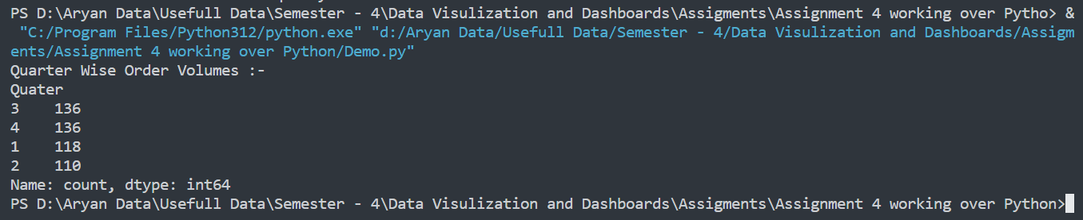**Output :-**

1. **How does order frequency vary over the month?**

**Code :-**

Month_Wise_Order = Dataset["Month"].value_counts()

print(f"Month Wise Order Frequency :-\n{Month_Wise_Order}")

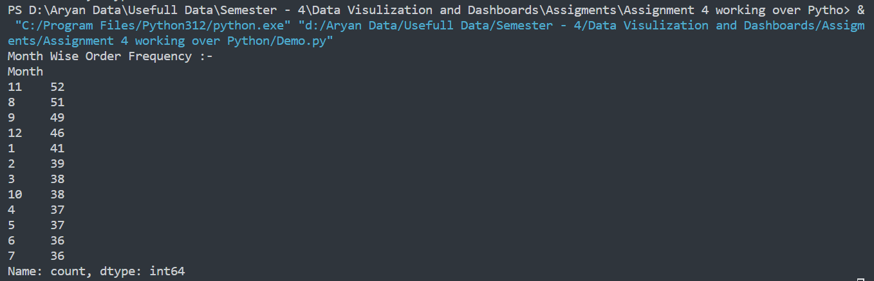**Output :-**

1. **Are there certain categories contributing more to revenue?**

**Code :-**

Total_Revenue = Dataset["Total_Cost"].sum()

Total_Revenue_From_Small_Category = (

Dataset[(Dataset["Order_Category"] == "Small Order")]["Total_Cost"].sum()

/ Total_Revenue

) * 100

Total_Revenue_From_Normal_Category = (

Dataset[(Dataset["Order_Category"] == "Normal Order")]["Total_Cost"].sum()

/ Total_Revenue

) * 100

Total_Revenue_From_Large_Category = (

Dataset[(Dataset["Order_Category"] == "Large Order")]["Total_Cost"].sum()

/ Total_Revenue

) * 100

print(

f"Category Wise Contribution :-\nSmall Category :- {Total_Revenue_From_Small_Category} %\nNormal Category :- {Total_Revenue_From_Normal_Category} %\nLarge Category :- {Total_Revenue_From_Large_Category}%"

)

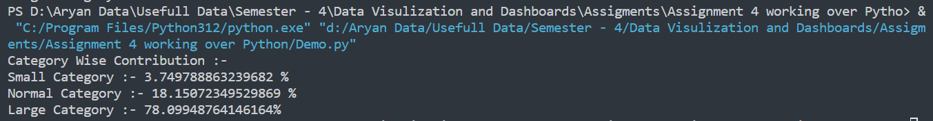**Output :-**

1. **What is the distribution of orders across different order categories?**

**Code :-**

Cateory_Wise_Distribution = Dataset["Order_Category"].value_counts()

print(Cateory_Wise_Distribution)

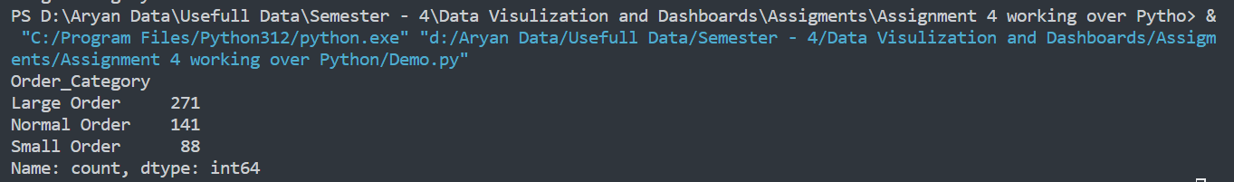**Output :-**

1. **Can you identify the most common product purchased in large orders?**

**Code :-**

Order_With_Large_Category = Dataset[(Dataset["Order_Category"] == "Large Order")]

Product_Distribution_In_Large_Orders = Order_With_Large_Category[

"Product_#"

].value_counts()

print(Product_Distribution_In_Large_Orders)

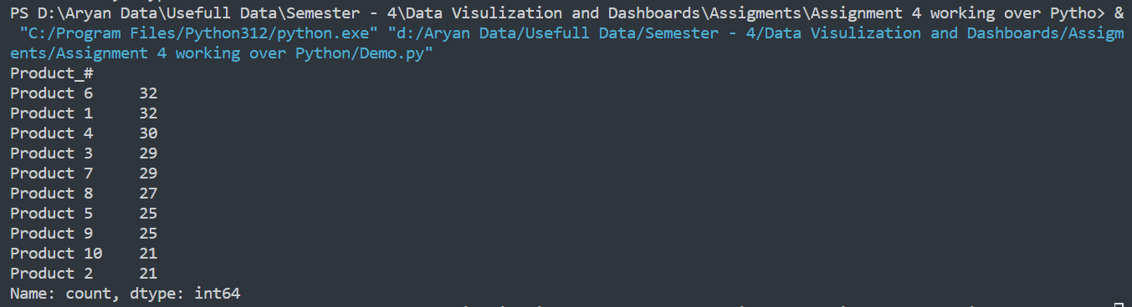**Output:-**

1. **What is the average quantity of products per order?**

**Code :-**

Average_Quantity = Dataset["Quantity"].mean()

print(Average_Quantity)

**Output :-**



1. **Which product has the highest unit price?**

**Code :-**

Product_With_Highest_Unit_Price = Dataset.loc[

Dataset["Unit_Price"].idxmax(), "Product_#"]

print(Product_With_Highest_Unit_Price)

**Output :-**

1. **What is the total revenue generated from large orders versus normal orders?**

**Code :-**

Total_Revenue = Dataset["Total_Cost"].sum()

Total_Revenue_From_Normal_Category = (

Dataset[(Dataset["Order_Category"] == "Normal Order")]["Total_Cost"].sum()

/ Total_Revenue

) * 100

Total_Revenue_From_Large_Category = (

Dataset[(Dataset["Order_Category"] == "Large Order")]["Total_Cost"].sum()

/ Total_Revenue

) * 100

print(f"The Large Category Has Generated {Total_Revenue_From_Large_Category} % and Normal Category Has Generated {Total_Revenue_From_Normal_Category} % of Total Revenue")

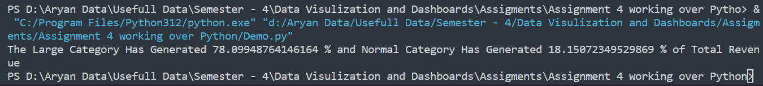**Output :-**

1. **What is the proportion of large orders to normal orders in the dataset?**

**Code :-**

Order_With_Large_Category = Dataset[(Dataset["Order_Category"] == "Large Order")]

Order_With_Normal_Category = Dataset[(Dataset["Order_Category"] == "Normal Order")]

print(f"The Proportion of Large Order Is {(Order_With_Large_Category.shape[0] / Dataset.shape[0]) * 100} % and Normal Order Is {(Order_With_Normal_Category.shape[0] / Dataset.shape[0]) * 100} %")

**Output :-**

1. **How many unique customers are represented in the dataset?**

**Code :-**

Unique_Customers = list(set(Dataset["Full_Name"]))

No_of_Unique_Customers = len(Unique_Customers)

print(f"There are {No_of_Unique_Customers} Unique Customers in the Dataset")

**Output :-**

1. **What is the most frequently purchased product across all orders?**

**Code :-**

Frequently_Purchased_Product = Dataset["Product_#"].mode()[0]

print(f"{Frequently_Purchased_Product} Is The Most Frequently Purchased Product")

**Output :-**



1. **What is the average total cost for each order category?**

**Code :-**

Order_With_Large_Category = Dataset[(Dataset["Order_Category"] == "Large Order")]

Order_With_Normal_Category = Dataset[(Dataset["Order_Category"] == "Normal Order")]

Order_With_Small_Category = Dataset[(Dataset["Order_Category"] == "Small Order")]

Average_Total_Cost_In_Large_Order = Order_With_Large_Category["Total_Cost"].mean()

Average_Total_Cost_In_Normal_Order = Order_With_Normal_Category["Total_Cost"].mean()

Average_Total_Cost_In_Small_Order = Order_With_Small_Category["Total_Cost"].mean()

print(f"Category Wise Average Total Cost :-\nSmall Category {Average_Total_Cost_In_Small_Order}\nNormal Cateogory = {Average_Total_Cost_In_Normal_Order}\nLarge Category = {Average_Total_Cost_In_Large_Order}"

)

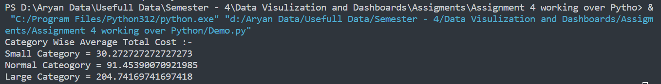**Output :-**

1. **How does the quantity of products impact the total cost in different order categories?**

**Code :-**

plt.figure(figsize=(16,8))

sns.barplot(x=Dataset['Quantity'] , y=Dataset['Total_Cost'] , hue=Dataset['Order_Category'])

plt.show()

**Output :-**

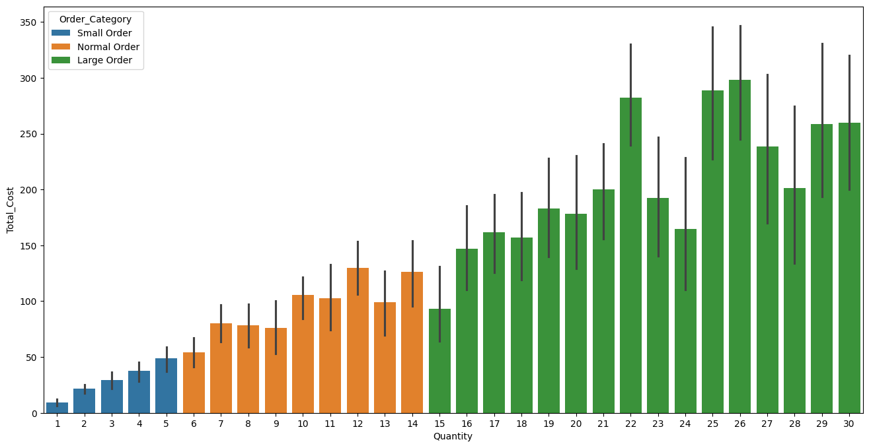

1. **What is the proportion of small, normal, and large orders in the dataset?**

**Code :-**

Order_With_Large_Category = Dataset[(Dataset["Order_Category"] == "Large Order")]

Order_With_Normal_Category = Dataset[(Dataset["Order_Category"] == "Normal Order")]

Order_With_Small_Category = Dataset[(Dataset["Order_Category"] == "Small Order")]

Orders_In_Large_Order = (Order_With_Large_Category.shape[0] / Dataset.shape[0]) * 100

Orders_In_Normal_Order = (Order_With_Normal_Category.shape[0] / Dataset.shape[0]) * 100

Orders_In_Small_Order = (Order_With_Small_Category.shape[0] / Dataset.shape[0]) * 100

print(f"Category Wise Proportion of Orders\nLarge Category :- {Orders_In_Large_Order} %\nNormal Category :- {Orders_In_Normal_Order} %\nSmall Category :- {Orders_In_Small_Order} %")

**Output :-**

